What Does the Graph Say?
Read the following graphs and answer the questions about each of them on your activity sheet.
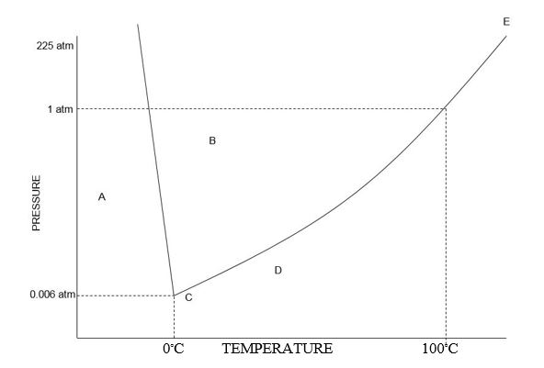
- What letter represents the triple point?
- What letter represents the solid phase?
- What letter represents the liquids phase?
- What letter presents the gas phase?
- What is the melting point of this substance?
- What is the boiling point of this substance?
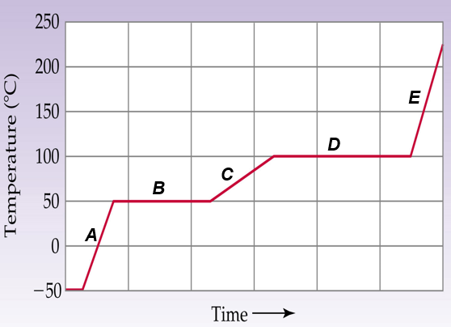
- What letter(s) represent an increase is potential energy?
- What letter(s) represent an increase in kinetic energy?
- What letter represents the solid phase?
- What letter represents the liquids phase?
- What letter presents the gas phase?
- What letter has the highest energy level?
- What letter has the lowest energy level?

